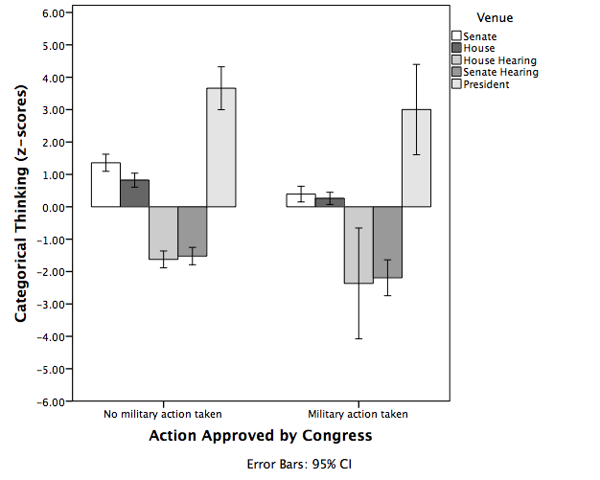

*Figure 3.* Main effect for action taking shown by venue for categorical thinking for Hypothesis 2. House and Senate hearings are from specific Foreign Affairs subcommittees of each venue.